Chyloma Formation After Anterior Cervical Disc Fusion
Theodore Klug
Courtney Shires
Merry Sebelik
Chyle leak is serious sequela of head and neck surgery and has been reported after esophageal, parathyroid, and thyroid surgery. However, it has only been reported postoperatively once before after anterior cervical disc fusion (ACDF). This case discusses the formation of a chyloma following an anterior cervical spinal procedure.
Case Report: Chyloma Formation After Anterior Cervical Disc Fusion
Theodore Klug, MD, MPH¹; Merry Sebelik, MD, FACS¹; Courtney B. Shires, MD, FACS¹
¹ West Cancer Center, 7945 Wolf River Blvd, Germantown, TN 38104
Corresponding Author:
Theodore Klug, MD, MPH
West Cancer Center
7945 Wolf River Blvd, Germantown, TN 38104
901-491-1721
theodklu@gmail.com
Author Contributions
Theodore Klug, MD, MPH: Collected data, wrote and edited article
Merry Sebelik, MD, FACS: Collected data, wrote and edited article
Courtney B. Shires, MD, FACS: Collected data, wrote and edited article
Financial Support: This particular research received no internal or external grant funding.
Conflicts of Interest: The authors report no relevant financial disclosures related to this current work.
Ethical Considerations: All issues related to ethics were taken into consideration throughout the study design and proposal and implemented during the research study itself. Informed consent was obtained, beneficence was made a top priority, and respect for confidentiality and privacy were upheld during the study and its various analysis and information assertation components.
Abstract
Background
Chyle leak formation is an uncommon but serious sequela of head and neck (H&N) surgery, including esophageal, parathyroid, and thyroid surgery. It has only been reported postoperatively twice after anterior cervical disc fusion (ACDF) to our knowledge. One prior case was repaired immediately during the initial spine surgery, and one prior case required postoperative needle aspiration.
Case Presentation
A 62-year-old obese male patient underwent anterior cervical disc fusion (ACDF) via a left sided neck approach. There were no issues intraoperatively and no chyle leak was noted. Four months later he presented to the clinic with lower left neck pain and swelling inferior to the incision. Exam and CT imaging showed a 4x4 cm left lower cervical abscess. He underwent transcervical incision and drainage. He required a second return trip to the operating room with ligation of the thoracic duct in the chest. He returned to a regular diet and had no further issues more than 5 years following the index operation.
Conclusions
We encountered a patient with a chyloma 4 months after ACDF. With neck pain and swelling following ACDF, chyloma should be considered as a part of the differential diagnosis. This is the only reported case that required open repair with ligation of the thoracic duct in the chest.
Key Words
Chyloma; thoracic duct; chyle; chyle leak; anterior cervical disc fusion; head and neck
Key Clinical Message
Chyle leak from iatrogenic thoracic duct injury is a rare but serious complication of head and neck surgery. The chyloma in this case took months to recognize and required open thoracic ligation. He fully recovered.
Case Presentation
The patient is a 62-year-old male with a BMI 24.2 who presented with cervical spinal disc disease. He had a herniated nucleus pulposus with associated radiculopathy at the level of C5-C6. He had hypertension, but no other comorbidities at the time of the initial surgery. He underwent anterior cervical disc fusion (ACDF) via a left sided neck approach. There were no complications intraoperatively and no chyle leak was noted. The patient was discharged home following the operation in stable condition. Four months later he presented to clinic with lower left neck pain and swelling inferior to the incision. Exam showed indurated and erythematous left neck and upper chest skin (Figure 1). He had no accompanying symptoms of fever or dysphagia. CT imaging showed a 4x4 cm left lower cervical abscess (Figures 2 and 3). He underwent transcervical incision and drainage. A JP drain was placed at that time. This drain had >1000 cc of cloudy output per day. ENT was consulted. The drainage was felt to be chyle. The patient was taken back to the OR with ENT and thoracic surgery. A fluid cavity with a capsule was noted. The chyloma was felt to have walled itself off. As this capsule was opened, copious chyle was released. The thoracic duct was noted inferior and lateral to the subclavian vein. This was ligated in the chest. Another JP drain was placed. The drain was observed postoperatively, and no further chyle leak was noted. The drain was removed after 5 days. He returned to a regular diet and had no further issues greater than 5 years following the index operation.
Discussion
The vast majority of lymphatic injury during spine surgery occurs in the thoracic and lumbar regions. Injury due to the close proximity of the thoracic duct and the cisterna chyli to the vertebral column results in chylothorax or chyloretroperitoneum. The incidence of thoracic duct injury following cervical spine surgery is substantially lower in than in thoracolumbar surgery. This may be due to the longer anatomic course of the thoracic duct in the thoracolumbar area as compared to the cervical spine. The height of the arch of the thoracic duct in the root of the neck also varies, and can be inferior to, at, or superior to the clavicle.¹ Langford et al reported that a thoracic duct can extend as much as 5 cm above the clavicle², and Hart et al described a case in which the arch was situated 7 to 8 cm above the clavicle.³ Also, there is significant deviation in the termination pattern of the thoracic duct as it joins the systemic circulation. It may end as single or multiple outlets into the left internal jugular vein, the left subclavian vein, the left external jugular vein, the left brachiocephalic vein, the left transverse cervical vein, or the right internal jugular vein.^{1,3-5}
Intraoperative identification of lymphatic injury can be difficult due to the usual fasting state of patients prior to surgery, which diminishes lymphatic production and transport. Thus cloudy lymphatic material may not be visible in the wound even if an injury exists. Valsalva administration or placing the patient in the Trendelenburg position may assist in identifying an intraoperative leak.
During head and neck surgery, chyle leak from iatrogenic thoracic duct injury is a rare but serious complication that occurs in 0.5–1.4% of thyroidectomies⁶⁻¹⁰ and 2–8% of neck dissections^{2, 6, 11-13}. However, it has only been reported postoperatively twice before following an anterior cervical disc fusion (ACDF). ¹⁴ Our case is the third case of chyle leak after cervical spine surgery.
Of the 3 reported cases of iatrogenic thoracic duct injury from ACDF (Table 1), 2 were male and 1 was female. All three of the patients were undergoing surgery focused on level C5-6 and were approached from the left side.
The patients were relatively healthy, with patient 1 being in an MVA, patient 2 having no comorbidities and patient 3 having hypertension. None of the patients were obese. The size of the postoperative chyle collection on imaging was 2.3 cm for Patient 2 and 4 cm for Patient 3. One of the 3 leaks was noted intraoperatively and was repaired immediately with clips. One of the leaks was noted after 2 months and was treated with needle aspiration. The third leak was noted 4 months after the initial surgery and required intrathoracic ligation of the thoracic duct. In the 2 patients with delayed leaks, there was no noted direct sizeable injury to the thoracic duct intraoperatively during initial surgery. Given the delayed presentation and return after 2 and 4 months following ACDF, the differential diagnosis before imaging and exploration was the formation of a post-op hematoma, seroma, or chyloma. Following imaging, drainage, and surgery, the suspicion of a chyloma was confirmed. We believe the chyloma likely occurred secondary to a retraction injury on a portion of her thoracic duct. There was a small leak that over time created a cystic capsule which contained the leak. Patient 3 had immediate release of significant chyle (after a drain had already collected 1000 mL) once this capsule was opened during subsequent repair, but Patient 2 was able to heal after a simple needle aspiration of 3.5 mL. These 3 patients show the range of leak severity after injury during ACDF.
Two patients were discharged the day after their initial ACDF, and one was discharged the same day as ACDF. As the ACDF surgery is trending towards an outpatient procedure, postoperative chyle leaks will often more likely be discovered in a delayed manner during an office visit, like Patients 2 and 3.
Presenting symptoms of the delayed leaks were nontender, mobile neck mass in Patient 2 and neck pain and swelling in Patient 3. No patient had postoperative fever, dysphagia, hoarseness, shortness of breath, or electrolyte abnormalities.
The 3 patients are doing well with follow up periods of 80 days, 3.5 years, and 5 years. Patient 3 who underwent thoracic duct ligation had no subsequent nutrition deficiency, as has been reported previously.¹⁵ After being addressed, patients may recover completely from this complication. None of these 3 patient has long-term side effects.
Conclusions
Chyle leaks can occur intraoperatively or become evident months after ACDF. Three cases have reported, with an incidence of <0.001%. These all occurred after surgery at the C5-6 level and a left sided approach. They present as lower neck swelling and pain. These can be treated postoperatively with needle drainage if small or open ligation of the thoracic duct if severe. Patients can experience a full recovery.
List of Abbreviations
Head and neck (H&N); anterior cervical disc fusion (ACDF); anterior cervical corpectomy and fusion (ACCF); postoperative day (POD)
References
1. Van Pernis PA. Variations of the thoracic duct. Surgery. 1949;26: 806-809.
2. Langford R. J., Daudia A. T., Malins T. J. A morphological study of the thoracic duct at the jugulo-subclavian junction. Journal of Cranio-Maxillo-Facial Surgery. 1999;27(2):100–104. doi: 10.1016/S1010-5182(99)80021-3.
3. Hart AK, Greinwald JH, Shaffrey CI, Postma GN. Thoracic duct injury during anterior cervical discectomy: a rare complication. Case report. J Neurosurg. 1998;88:151-154.
4. Gottlieb MI, Greenfield J. Variations in the terminal portion of the human thoracic duct. AMA Arch Surg. 1956;73:955-959.
5. Kinnaert P. Anatomical variations of the cervical portion of the thoracic duct in man. J Anat. 1973;115:45-52.
6. Delaney SW, Shi H, Shokrani A, Sinha UK. Management of Chyle Leak after Head and Neck Surgery: Review of Current Treatment Strategies. Int J Otolaryngol. 2017;2017:8362874. doi:10.1155/2017/8362874
7. Lee Y. S., Kim B.-W., Chang H.-S., Park C. S. Factors predisposing to chyle leakage following thyroid cancer surgery without lateral neck dissection. Head & Neck. 2013;35(8):1149–1152. doi: 10.1002/hed.23104.
8. Lorenz K., Abuazab M., Sekulla C., Nguyen-Thanh P., Brauckhoff M., Dralle H. Management of lymph fistulas in thyroid surgery. Langenbeck’s Archives of Surgery. 2010;395(7):911–917. doi: 10.1007/s00423-010-0686-2.
9. Roh J.-L., Yoon Y.-H., Park C. I. Chyle leakage in patients undergoing thyroidectomy plus central neck dissection for differentiated papillary thyroid carcinoma. Annals of Surgical Oncology. 2008;15(9):2576–2580. doi: 10.1245/s10434-008-0017-9.
10. Rammal A., Zawawi F., Varshney R., Hier M. P., Payne R. J., Mlynarek A. M. Chyle leak: a rare complication post-hemithyroidectomy. Case report and review of literature. Otolaryngologia Polska. 2014;68(4):204–207. doi: 10.1016/j.otpol.2014.03.003.
11. Dhiwakar M., Nambi G. I., Ramanikanth T. V. Drain removal and aspiration to treat low output chylous fistula. European Archives of Oto-Rhino-Laryngology. 2014;271(3):561–565. doi: 10.1007/s00405-013-2534-9.
12. Nussenbaum B., Liu J. H., Sinard R. J. Systematic management of chyle fistula: the Southwestern experience and review of the literature. Otolaryngology—Head and Neck Surgery. 2000;122(1):31–38. doi: 10.1016/s0194-5998(00)70140-9.
13. Crumley R. L., Smith J. D. Postoperative chylous fistula prevention and management. The Laryngoscope. 1976;86(6):804–813. doi: 10.1288/00005537-197606000-00008.
14. Derakhshan A, Lubelski D, Steinmetz MP, et al. Thoracic Duct Injury Following Cervical Spine Surgery: A Multicenter Retrospective Review. Global Spine J. 2017 Apr;7(1 Suppl):115S-119S. doi: 10.1177/2192568216688194. Epub 2017 Apr.
15. Bonavina L, Saino G, Bona D, Abraham M, Peracchia A. Thoracoscopic management of chylothorax complicating esophagectomy. J Laparoendosc Adv Surg Tech A. 2001;11:367-369.
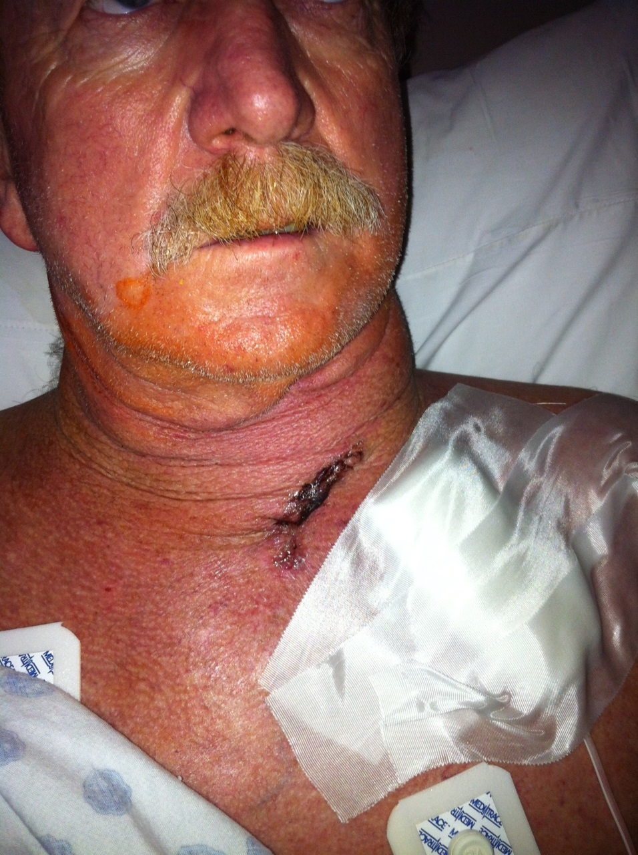
Figure 1. Indurated and erythematous left neck and upper chest skin 4 months after initial surgery.

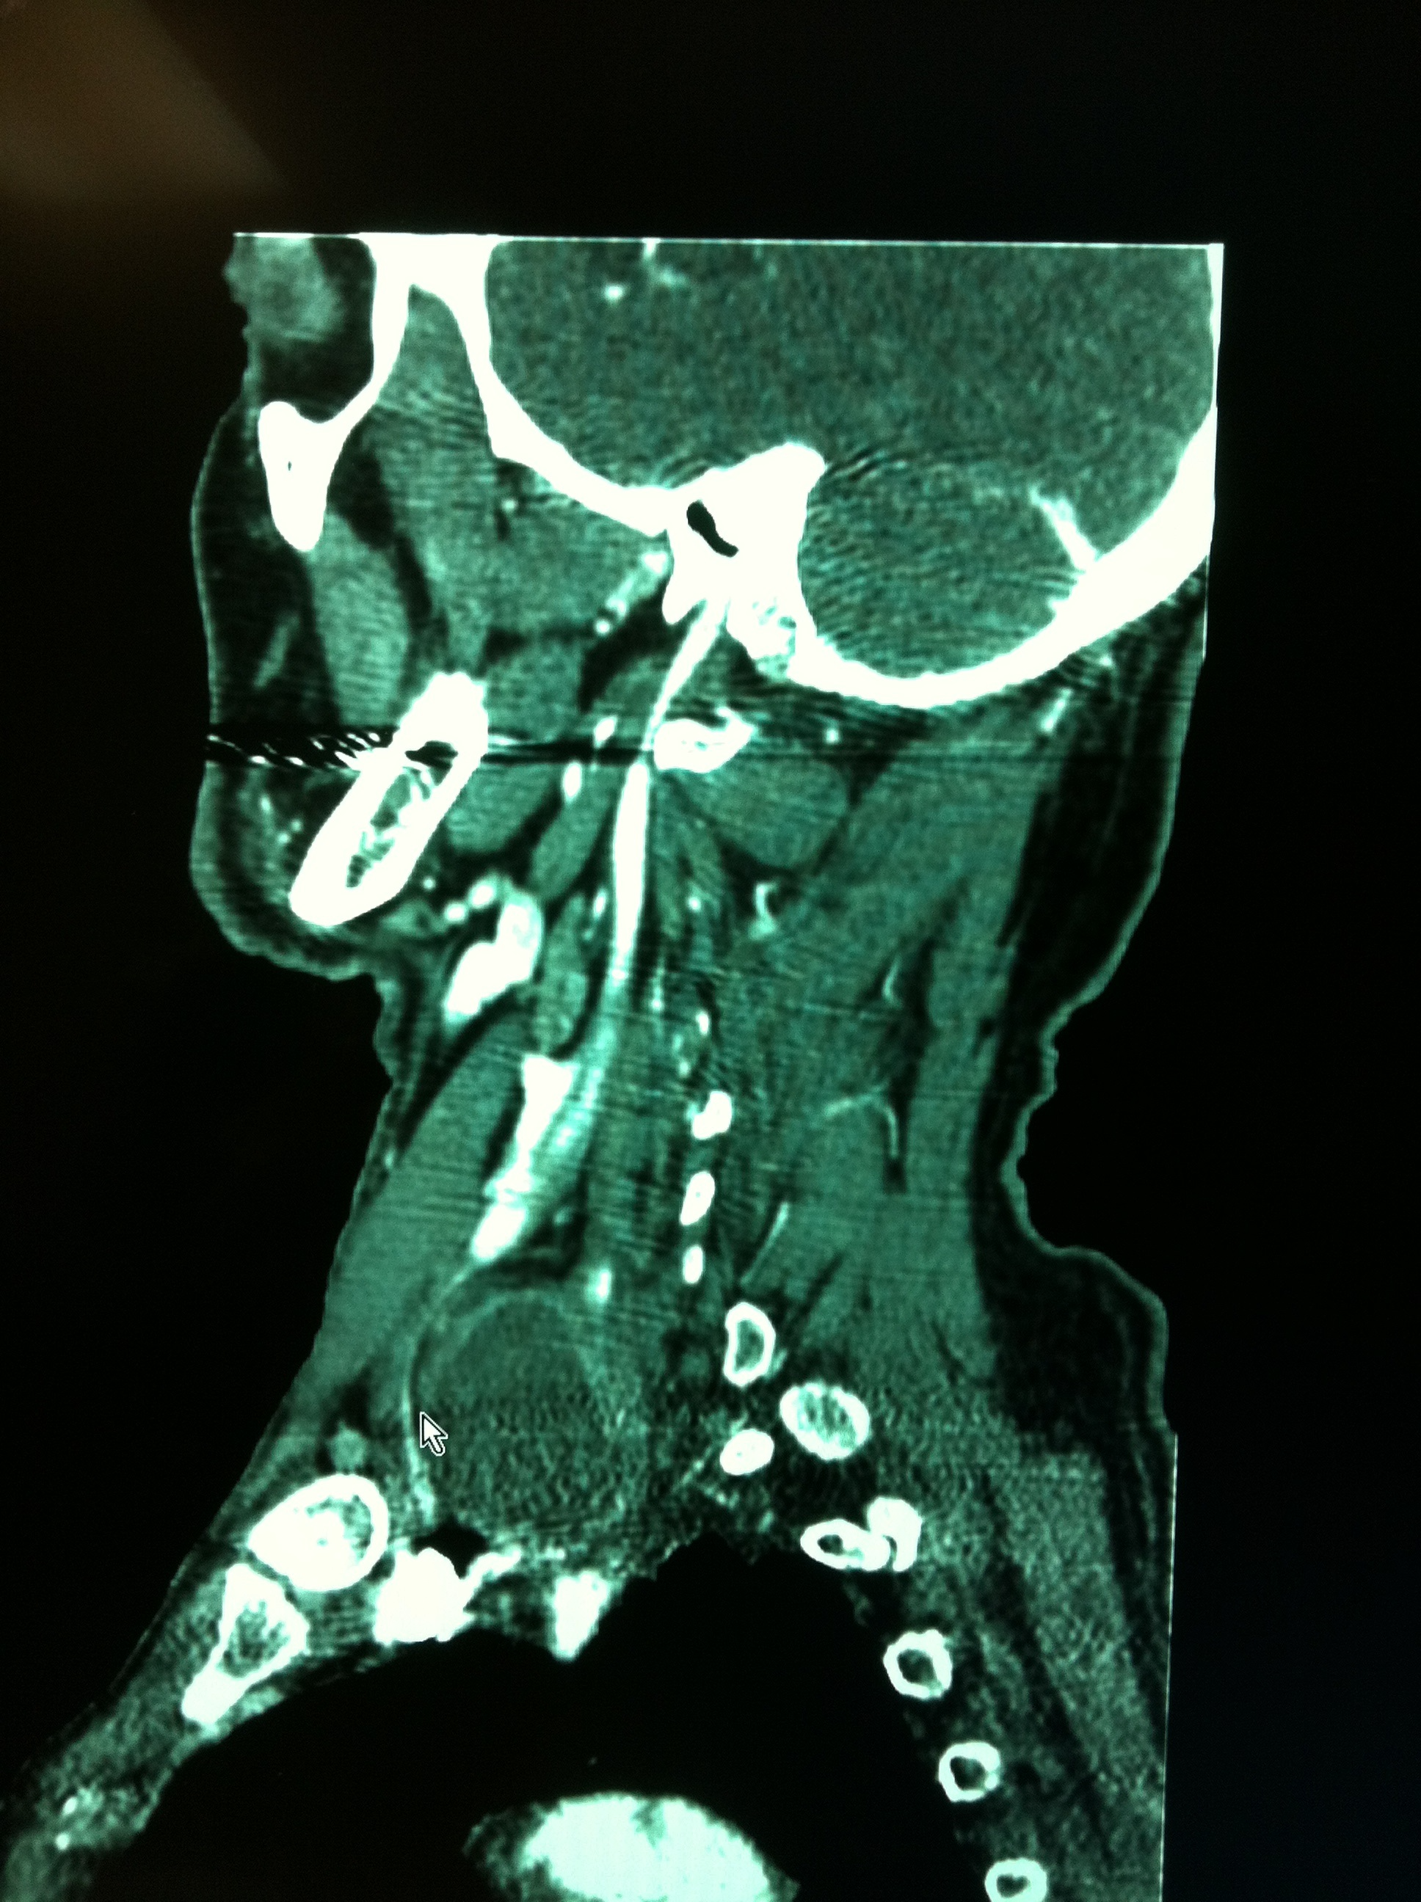
Figure 2. Sagittal CT imaging showing a 4x4 cm left lower cervical abscess.

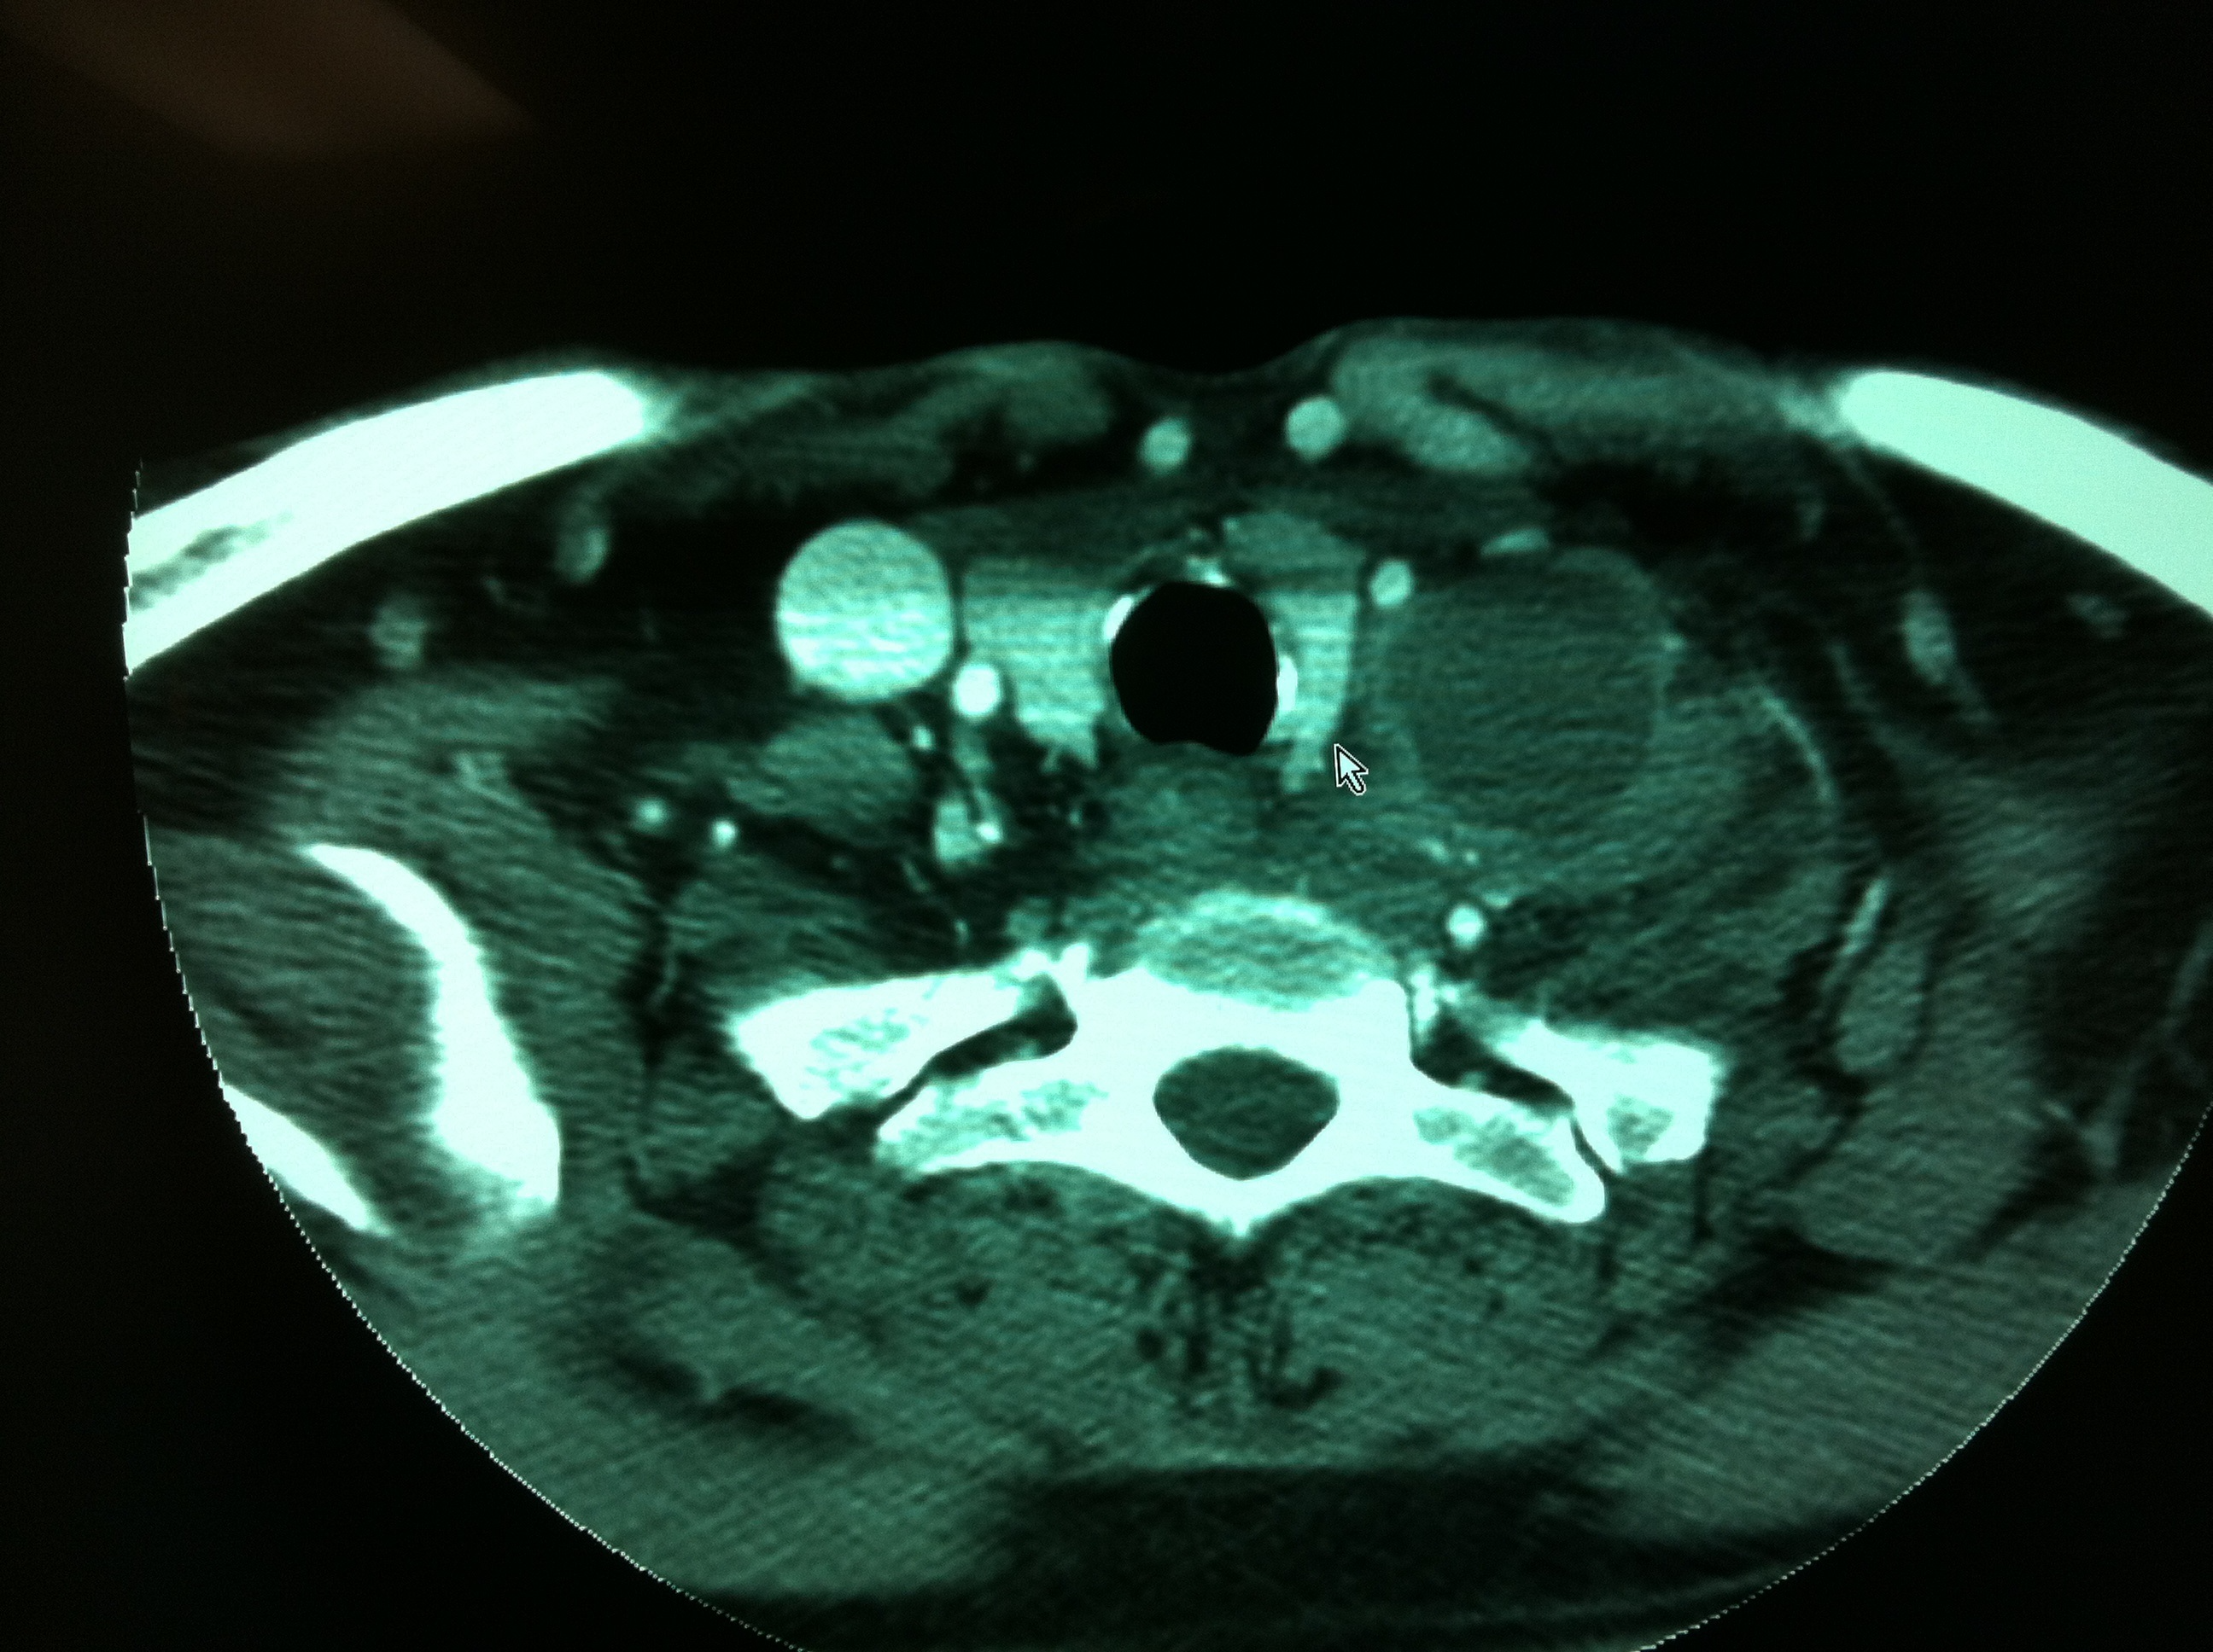
Figure 3. Axial CT imaging showing a 4x4 cm left lower cervical abscess.

Table 1.
Patient | age of pateint | sex | BMI | level of spine surgery | approach side | time leak noted | method of repair | size of fluid collection on imaging | date of initial discharge | symptoms | length of follow up
1 | NA | M | NA | C5-6 | left | intraoperative | clips | NA | postoperative day 1 | NA | 80 days
2 | NA | F | 21.9 | C5-6 | left | 2 months postoperatively | needle aspiration | 2.3 cm | same day | nontender, mobile neck mass | 3.5 years
3 | 62 years old | M | 24.2 | C5-6 | left | 4 months postoperatively | ligation of thoracic duct in the chest | 4 cm | postperative day 1 | neck pain and swelling | 5 years

